**BD Professionals Documentation**

* **Requirement Features Analysis:**

Requirement for our website-

1. Sign up
2. Login
3. View Repairman
4. Update/delete Account
5. Give offers
6. View/Apply for offers
7. Search/View Freelancers
8. Make Approvals of own offers
9. Logout

* **Requirement Features Full fills:**

From the above requirement features, feature number 4 update/delete profile not yet completed.

* **Database Design and System Layout Diagram:**
* **Use case diagram**

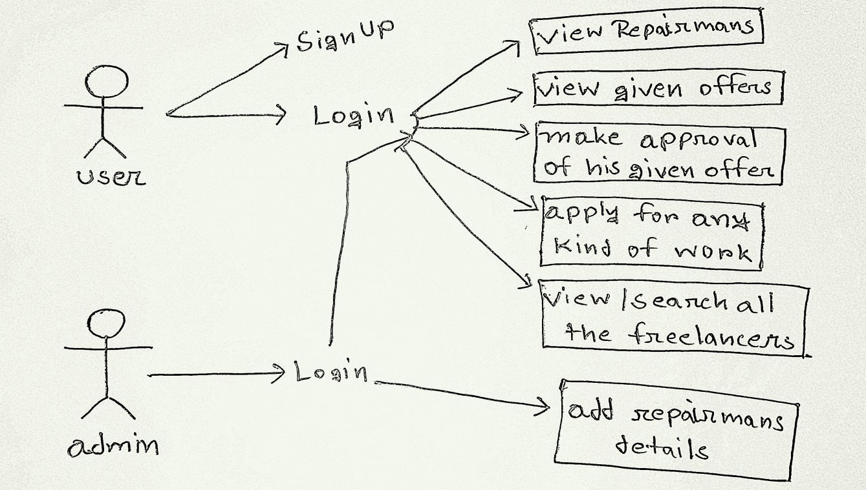

* **E-R Diagram  
  